Read what others are saying about

A Woman's Guide to Saving Her Own Life
From the Foreword…
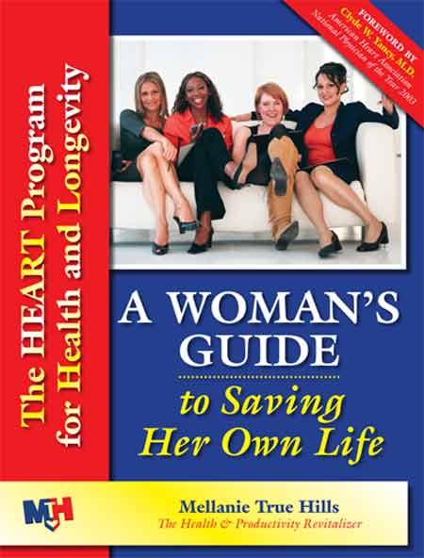
This book chronicles a real life story of a remarkable woman struck by heart disease and the resultant rally
of her human spirit that led to a restoration of her health. Mellanie has researched an impressive repository
of information on heart disease and has crystallized the HEART program designed especially for women.
Part 2 is about what every woman should know about heart disease, but every man should read it, too.
I highly recommend it.
—Clyde W. Yancy, MD, Professor of Medicine,
Director of the Cardiovascular Institute, St. Paul University Hospital;
American Heart Association National Physician of the Year 2003

An excellent read to learn about preventing or heading-off heart disease and its complications at an early stage.
—Boyd Lyles, Jr., MD, Founding Director, The HeartHealth and Wellness Center;
Former Associate Medical Director, The Cooper Clinic
Mellanie has not only shown us a way to save our own lives but actually how to reclaim them.
—Linda Byars Swindling, JD, Author, The Consultant’s Legal Guide;
National Director, National Speakers Association
I loved this Guidebook—incredibly informative, easy to read, and a must-have for every woman!
—Lori Parker, Morning News Anchor, K-EYE TV (CBS)
Mellanie scared me into recognizing that today's bad habits can be tomorrow's life threatening health issues. Fortunately, she provides us with a robust but easily understood explanation of heart disease and its causes, as well as a logical plan for taking control of our heart health. Written in layperson's terms, the book provides more than just explanations--it provides a wealth of tools such as a risk factors worksheet, goal setting tools, and detailed information on how to eat healthy without sacrificing taste. A Woman's Guide to Saving Her Own Life is a must read for any woman intent on avoiding the pitfalls of heart disease, or for anyone who wants to make a positive impact on their health.
—Karen Hiser, HealthyTravelNetwork.com
Mellanie exemplifies a true Transformational Leader, offering her story as a springboard to alert and inform others. She provides compelling testimony for women to take charge and lead heart-healthy lives. Mellanie gets to the “heart of it.”
—Diane McIntyre, Executive Director, American Heart Association, Austin, Texas
An engaging, compelling book that will save lives. As a journalist, I read many health stories and hear many personal tales of survival, but none have been so helpful and "from the heart" as Mellanie's.
—Lorri Allen, News Director, FamilyNet
I like her writing style—it's like having an intimate conversation with a good friend.
—Claudia Snow, Owner, Snow Construction Company
This book should grab the attention of Type A women who think they are invincible! Mellanie has delivered the women's heart book that is already saving lives. She is doing for women's heart disease what other women have done for breast cancer—getting the REAL facts out!
—Susan Macaulay
A great mix of personal stories and facts and a terrific sense of humor!
—Gayle Golladay

A Woman's Guide to Saving Her Own Life: The HEART Program for Health & Longevity, by Mellanie True Hills, is published by Healthy Ideas Press. First edition, soft cover, 8 ½ x 11, 196 pages, with 85 illustrations. ISBN 0-9766008-0-3. $39.95. Publication: Summer 2005.

Healthy Ideas Press • 13213 N Ridge Circle, Leander, TX 78641 • 512-267-5610 • info@SaveHerLife.com

