For Immediate Release . . .
Contact: Healthy Ideas Press, 512-267-5610 or info@SaveHerLife.com

"This book chronicles a real life story of a remarkable woman struck by heart disease and the resultant rally of her human spirit
that led to a restoration of her health. Mellanie has researched an impressive repository of information on heart disease
and has crystallized the HEART program designed especially for women. I highly recommend it." From the
Foreword by Clyde W. Yancy, MD, American Heart Association National Physician of the Year 2003

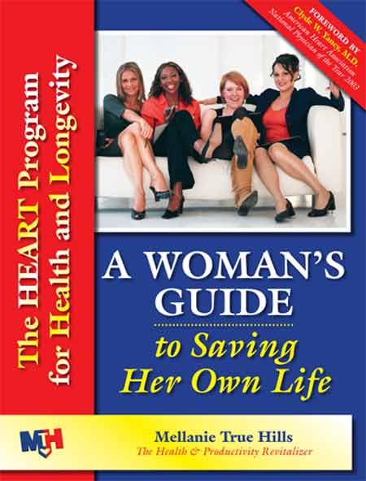
Escape the Silent Killers Stalking You
Most women don't know that breast cancer isn't their worst enemy. Two silent stalkers—heart disease and stroke—kill two of every five women, largely due to our speed-obsessed, stressed, unhealthy lifestyles. Every minute, we lose one woman to heart disease or stroke in the US, and two-thirds of them had no prior symptoms. It's happening to younger and younger women—women in their forties, thirties, even twenties. Why are we losing this battle? Because women have different symptoms from men—subtle, easily-overlooked symptoms—that many women, and their doctors, don’t know.
A Woman's Guide to Saving Her Own Life empowers women to take control of their life and health.

Mellanie True Hills, author of A Woman's Guide to Saving Her Own Life, almost died in emergency heart surgery. She didn’t even have the traditional heart attack risk factors—she was simply overweight and overstressed, just like many women today. As a high-tech road warrior with an extreme job and an always-on lifestyle, she almost died from stress. Shockingly, more than half of all executives will die from stress-related illnesses. Many women are headed for this same train wreck, but the secrets that saved Mellanie could save them, too.

Knowing what to do can save your life!
This guidebook helps you recognize the blinking red warning lights of your health and evade these silent killers at any age. This approachable, easy-to-read book provides explanations, tools, assessments, and five easily-implemented steps to:
- Identify and control your risks—including lifestyle—and create a plan you can actually stick to
- Lose weight easily . . . Mellanie lost 85 pounds with these secrets
- Find out why working women have more stress and how they can avoid it killing them
- Help your doctor give you the treatment and tests you deserve
- Recognize that women have different symptoms—knowing the difference can save your life
- Share with men in your life what they need to know

The HEART Program in A Woman's Guide to Saving Her Own Life has saved countless lives and could save yours, too!

Mellanie True Hills authored two intranet best-sellers (John Wiley & Sons) and A Woman’s Guide to Saving Her Own Life. As a recovering road warrior, she uses her second chance to raise awareness of women and heart disease and to coach individuals to create healthy lifestyles and organizations to create healthy, productive workplaces.

A Woman's Guide to Saving Her Own Life will be available for $39.95 in bookstores, at www.SaveHerLife.com, and by calling Healthy Ideas Press at 866-966-1437.

-30-

A Woman's Guide to Saving Her Own Life: The HEART Program for Health & Longevity, by Mellanie True Hills, is published by Healthy Ideas Press. First edition, soft cover, 8 ½ x 11, 196 pages, with 85 illustrations. ISBN 0-9766008-0-3. $39.95. Publication: Summer 2005.

Healthy Ideas Press • 13213 N Ridge Circle, Leander, TX 78641 • 512-267-5610 • info@SaveHerLife.com

